Phoenix Ambulatory Blood Pressure Monitoring System

Project Overview – 4Q2009

Need
Blood pressure is highly variable. Abnormal blood-pressure and heart-rate variability is not trivial as it is associated with increased risk of vascular disease, including hypertension, heart attack, stroke, kidney disease, retinopathy, and other major handicapping and fatal diseases.
Certain vascular variability disorders can be treated and their treatment is associated with improved outcomes.
- MESOR-Hypertension – hypertension as indicated by measurements taken throughout multiple days
- Circadian Hyper-Amplitude-Tension (CHAT) – excessive circadian variation of blood pressure
- Decreased Heart-Rate Variability – decreased standard deviation of heart rate
- Elevated Pulse Pressure – too large a difference between diastolic and systolic blood pressure (between when the heart contracts and relaxes, respectively)
- Circadian Ecphasia – odd timing of the circadian diastolic blood pressure rhythm

These disorders are understood through techniques of chronobiology, which concerns the timing of biological events in individual organisms – aging, biological rhythms, repetitive or cyclic phenomena. The chronobiologic approach relies on periodic, around-the-clock measurement of blood pressure, and interprets circadian amplitude and phase in the light of time-, gender-, and age-specified norms. Such an approach has better predictive value than day-night ratios, which rely on less sophisticated analysis of around-the-clock measurements; and much better value than singular measurements, which are the current norm.
The chronobiologic approach is practiced, however, on a small scale only. Inexpensive and easy-to-use technology is needed to expand the availability of chronobiology and chronomedicine. The Phoenix program is a catalyst of that technology.

System Vision
Phoenix envisions the wherewithal to understand the dynamic profile of a person’s blood pressure over the span of at least a week.

The Phoenix system will measure:
- Blood pressure
- Heart rate

The system will record measurements:
- Repetitively – nominally every 30 minutes but the period will be adjustable
- Around-the-clock, day and night
- For seven days or longer, at the nominal period

The system will include analysis tools appropriate for:
- Self care
- Diagnosis
- Prevention & Pre-habilitation
- Treatment & Re-habilitation

The system will be usable:
- Long term
- On a massive scale

Project Mission
The goal of Phoenix is to develop:
- An ambulatory blood pressure monitor that is:
  - Inexpensive
  - Unobtrusive
  - Easy to use
  - Collects a week of blood pressure measurements
- Software for:
  - Chronobiological analysis of collected blood pressure measurements

The Phoenix Project, with its development and launch of the monitor and software, is a first step toward the system vision. The Phoenix program includes two other endeavors:
- The Phoenix Measurement Program will work toward large-scale deployment of the system for self-care, education, research and public health. The program’s aim is to obtain measures of normal health.
- The Phoenix Clinical Program will work toward use of the system to prevent, detect, and treat disease. It will focus on medical practice, education and services.

Phoenix is a nonprofit group working under an "open source" model. As such, we will significantly reduce the research and development costs, and therefore the final consumer price, of these new ambulatory blood pressure monitors. The open source model encourages a build-up of services around a technology – in this case, useful healthcare services.
The monitor and software developed by the project is envisioned as a first-generation system. The system architecture and the open source model anticipate multiple medical device manufacturers picking up our designs and using them as the basis for their own products. The project is less concerned with bringing the technology to market as with enabling others to do so.

Operational Scenarios
Phoenix envisions a blood pressure monitor and software with the potential for:
- Home-based self care
- Internet-based individual health surveillance
- Clinical care
- Self-care followed by clinical care
- Public health care
- Education at the primary, secondary and undergraduate levels
- Research into both internal and external sources of cardiovascular rhythms
- Sports training
- Emergency medical service
- Combat lifesaving

Figure 1 illustrates a system that advances self and clinical care with transdisciplinary scientific research, while safeguarding anonymity, privacy and security with lifelong follow-up.
Figure 1. Operational Scenarios

Architectural Vision
Architectural Requirement | Forces
Inexpensive | - Main driver for open source  - Free intellectual property, volunteer labor
Highly decomposed | - Consequence of open source  - Each component quickly engineered by a very small team (usually one person)
Extensible – highly recomposable | - Consequence of multiple actors, vaguely organized  - Evolving user classes, usage scenarios, environments  - Highly re-usable components  - Open protocols
Scalable | - Ready to cope with increasing volumes of:  - Wearers  - Acquired data  - Analysis requests
Distributed | - Consequence of massive scale involving diverse actors
Secure and preserves privacy | - Guiding principles:  - Wearer owns measurements of the wearer’s body  - Caregivers are custodians  - Control belongs to the wearer

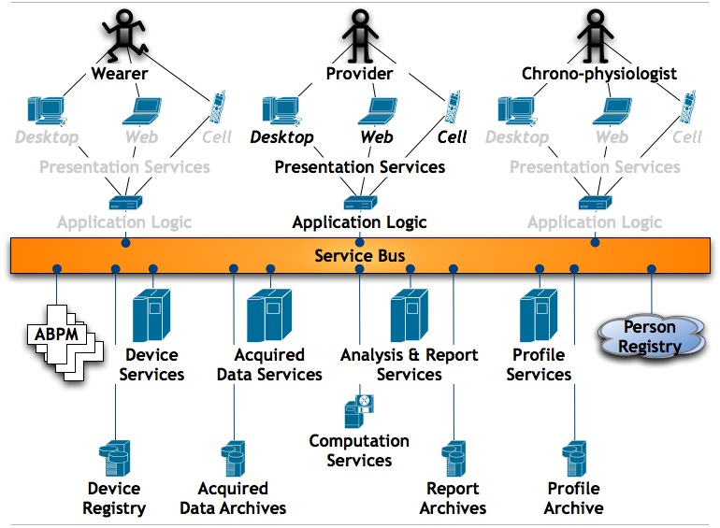
Figure 2. Service-Oriented System Architecture

Underlined terms are defined at http://www.phoenix.tc-ieee.org/014_Systems_Architecture_and_Engineering/shared/glossary.html.
Modified by Mary Sampson from Figure 1 (Phoenix Architecture) in Adams C. Privacy requirements for low-cost chronomedical systems. Int Conf on the Frontiers of Biomedical Science: Chronobiology, Chengdu, China, September 24-26, 2006. cf. 64-69. See also Halberg F, Cornelissen G, Otsuka K, Siegelova J, Fiser B, Dusek J, Homolka P, Sanchez de la Pena S, Singh RB, BIOCOS project. Extended consensus on need and means to detect vascular variability disorders (VVDs) and vascular variability syndromes (VVSs). Geronto-Geriatrics: Int J Gerontology-ChronomeGeriatrics 2008; 11 (14): 119-146 and Leibniz-Online Nr. 5, 2009 (http://www.leibniz-sozietaet.de/journal). 35 pp.

